
Patient Information
Patient Name:__________________________________________________ Today’s Date:________________
SSN:______________________________ DOB:____________________ Gender: Male _____ Female_____
Legal Address:_________________________________________________ City: ________________________
State:__________ Zip Code:_________ Months of Residence: From:_______________ To:__________________
Alternate Address:_______________________________________________ City:________________________
State:__________ Zip Code:___________ Months of Residence: From:_______________ To:__________________
Home Phone: ______________________ Cell Phone:___________________ Work Phone:________________
Email Address:__________________________________________________________
Employer:______________________________________________________________
Referring Physician:__________________________ Primary Care Physician:_______________________
Emergency Contact:___________________________Relationship:_______________Phone:_____________
Nature of Illness/Injury
Date of Onset/Surgery:______________ Body part to be treated:_____________ Left/Right:__________
Is this injury WORK or AUTO related?__________________________ (If yes please Circle which one)
Insurance Information
Have you received any physical therapy this year? Yes/No if “Yes”, when?___________________
Name of Facility:___________________________ Discharge Date?________________________
Primary Insurance:_________________________ Policy#:_________________ Group#:_____________
Subscriber:_____________________ Subscriber’s SSN:_________________Subscriber’s DOB:_________
Secondary Insurance:_________________________ Policy#:_________________ Group#:_____________
Subscriber:_____________________ Subscriber’s SSN:_________________Subscriber’s DOB:_________
Acknowledgement of Notification of Privacy Practices
By Signing below you acknowledge the availability of our “Notice of Privacy Practices” pamphlet which provides information about how we may use and disclose you protected health information and is compliant with the Health Insurance Portability and Accountability Act of 1996(HIPPA). We reserve the right to change the terms described, and should we will post the changes in all of offices. You have the right to request restrictions on how your protected health information may be used or disclosed for treatment, payment or health operations. We are not required to agree with your restrictions; but if we do we are bound by our agreement with you. ** Please Note: In accordance with Florida Law we may destroy patient charts 6 years after the last documented record. In the case of a minor, records must be retained until the patient reaches the age of 18 plus 3 years, or for 5 years after the record was made whichever is later**

Patient or Guardian Signature:____________________________________ Date:__________________

Patient Health Questionnaire
Name:_____________________________________ Today’s Date: ______________ Date of Birth: ______________
Body Part:__________________________________ Date of Injury:_____________ Date of Surgery:____________
Occupation: _____________________
Work Status: _____ Regular _____ Light Duty _____ not working due to this problem _____ Retired _____ Other
Mark on the picture where you have symptoms: 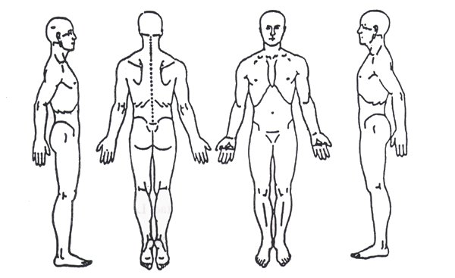
Type of Symptoms you are experiencing (circle all the apply):
Sharp Stiff Burning Tingling Numbness Stiffness Aching Swelling Throbbing
The amount of pain you are experiencing in a day: (circle the appropriate answer)
Constantly (75-100%) Frequently (51-74%) Occasionally (26-50%) Intermittently ( 0-25%)
What make symptoms better?_________________________________________________________________
What make symptoms worse?_________________________________________________________________
Please rate the following on a scale of 0-10 (0 = No pain, 10= worst pain imaginable)
- Your current pain level: _____out of 10
- The most pain that you’ve had in the past week _____ out of 10
- The least pain that you’ve had in the past week _____ out of 10
How are you sleeping at night? (circle the most accurate answer)
Fine, No problem Moderately Only with Medication Not at all
Medical History- Please check all that apply:
Heart Problems |  | Low/High Blood Pressure |  | Osteoporosis |  | TMJ |  | Back or Neck Problems
Pacemaker |  | Cancer |  | Epilepsy |  | Arthritis |  | Lung Disease
Heart Attack |  | Difficulty Swallowing |  | Kidney Problems |  | Headaches |  | Latex Allergy
Dizziness |  | Hypoglycemia |  | Asthma |  | Diabetes |  | Pregnancy
Please List Medications including the dosage you are currently taking: _________________________________________
__________________________________________________________________________________________________
Please List Major Surgeries you have experienced:_________________________________________________________

Patients Informed Consent and Financial Policy
I, ________________________, The undersigned, acknowledge that I have agreed to participate in the plan of care for the treatment of the condition for which I was referred by my physician to restore acceptable levels of functional ability.
I understand that the treatment may consist of a variety of therapeutic procedures including, but not limited to; Manual therapy, therapeutic exercised (including progressive resistance exercise and aerobic activity), electrical stimulation, ultrasound, muscle testing, functional activities, traction, vasopneumatic devices, and other forms of intervention appropriate for my condition.
I also understand that I have the right to discontinue and/or refuse treatment at any given time. I will not hold the licensed and support staff of Edge Physical Therapy liable in the event I discontinue and/or refuse care during the course of my treatment plan.
Late Cancellation/No Show Policy
We request that you notify us by phone, at least 24 hours prior to your scheduled appointment, If you fail to keep your appointment or do not cancel 24 hours prior to your appointment time, you will be issued a $25.00 Late cancellation/no-show fee.
Insurance/Financial Responsibility
As a courtesy, Edge Physical Therapy will verify your insurance coverage. However, this is only an estimate of your insurance benefits, and is in no way a promise on behalf of the Insurance Company to pay for services provided.
All Patient deductibles, co-pays, co-insurance, and cash services are due at the time of treatment. We do not accept liens under any circumstances.
- I hereby assign all insurance benefits (Private, Medicare, and Worker’s compensation) to be paid directly to Edge Physical Therapy.
- I understand that if my insurance benefits do not cover or approve payments for services provided by Edge Physical Therapy, Then I am financially responsible and obligated to pay for all charges related to the services provided.
- I understand that payment of all charges incurred is my responsibility, and a $30.00 late fee per month will be charged on accounts 30 days past due.
- I understand there my be a $30.00 administrative fee if checks are returned. We reserve the right to discontinue treatment if you fail to comply with our office policies as stated above.
By Signing below I agree to all terms listed above:

Patient/Guardian Signature _________________________________________ Date: ________________

